### 

**Home Page Menu Bar Structure:**

1. About Us

2. Brand Arc (Case Study Articles with images)

3. Cultural Fuels (Social Impact Articles with images)

4. Inspirers (Top Features + People their journeys)

5. Portfolio (Community People here can curate their own portfolio and offer their service or consultation)

6. Connect (Contact details and social links)

**1. About Us**

Inspirer Co is a creative intelligence platform founded by brand marketer Arunima Kar, designed to connect creative minds with inspiration, insights, and meaningful recognition.

We celebrate the work of individuals whose contributions deserve more recognition, while providing a space for creative professionals to think, experiment, connect, and thrive without pressure. Our goal is to help creative professionals overcome everyday creative blocks, foster collaboration, and turn inspiration into work that truly makes an impact.

At Inspirer Co. we believe creativity flourishes when talent is nurtured, acknowledged, and given the freedom to explore. This is a space where curiosity meets connection, ideas turn into action, and professional growth happens naturally.

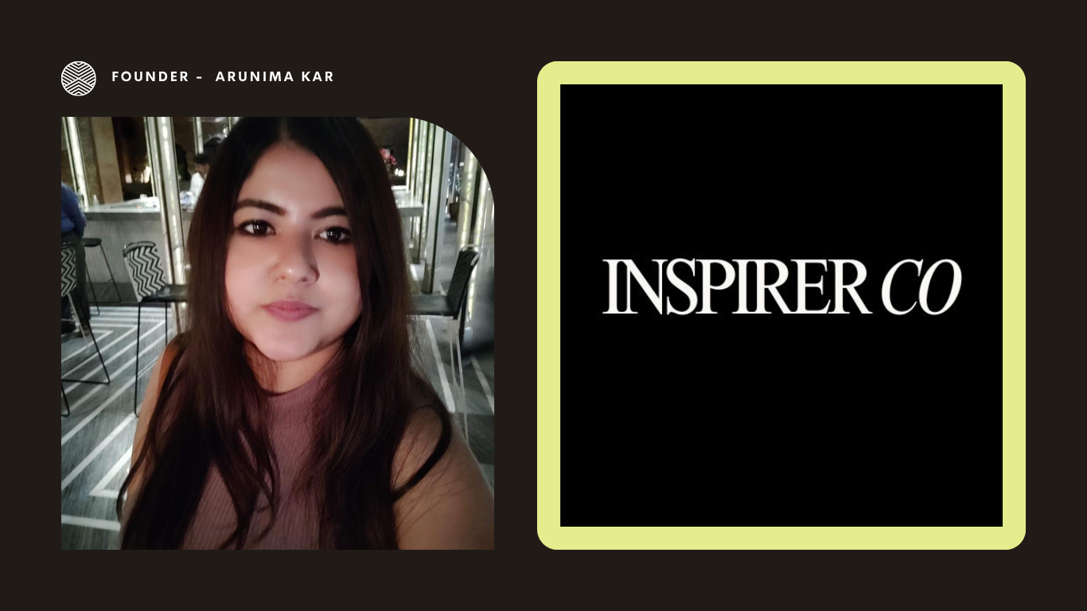

**2. Brand Arc: From Product to Philosophy**

## **Wakefit Festive Campaign Featuring Biswa Kalyan Rath:**

## **Sleep Right, Shop Right When Humor Meets Home Sense**

## **The Sleep Edit**

### 🧭 Slug (URL-friendly):

wakefit-biswa-kalyan-rath-festive-campaign-2025

### 💡 SEO Title:

Wakefit × Biswa Kalyan Rath: How Humor, Sleep, and Storytelling Redefined India’s Festive Season 2025

### ✍️ Meta Description:

From Diwali to Christmas and the wedding season, Wakefit’s campaign with Biswa Kalyan Rath proves that wit and wellness can win hearts. “Sleep is Mast, Biswa is now Swasth” reminds festive India that good sleep, not overconsumption, is the best celebration.

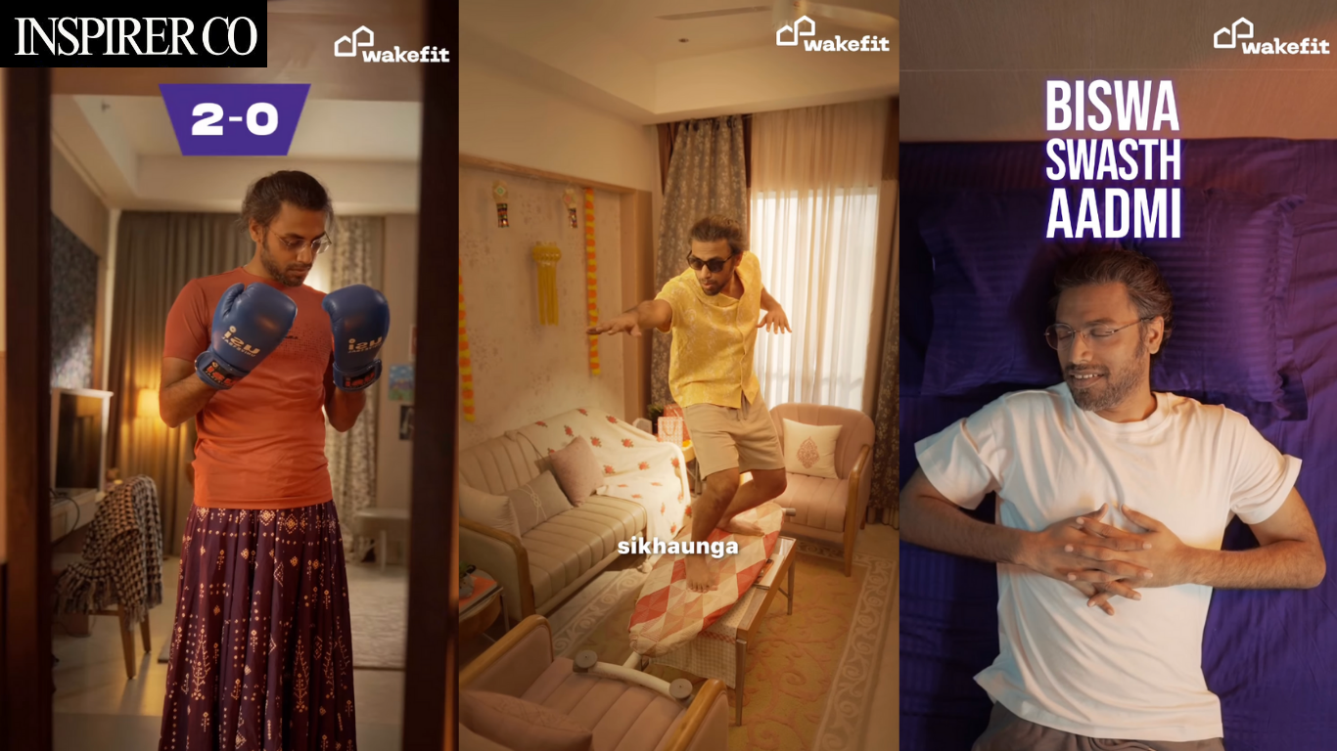

The Ad That Made Us Laugh and Think

This Diwali, Wakefit stepped away from emotional clichés and instead tapped into India’s collective exhaustion from the festive sale season. Starring comedian Biswa Kalyan Rath, the campaign *“Sleep is Mast, Biswa is now Swasth”* opens with a familiar sight: a late-night scroller impulsively buying things online. From the first doorbell ring to Biswa’s hilariously awkward chat with the delivery guy, it’s a mirror of modern India’s sleepless hustle.

In an age of 5-second reels, Wakefit dared to go slower and won. The pacing feels cinematic, confident that good storytelling can still hold an audience. When content respects attention, attention returns.

Wakefit takes a cultural truth, India’s sleepless, hyper-connected consumer habit, and turns it into insight. In a world addicted to reels and flash sales, the ad reminds us that instant doesn’t always mean intelligent. And yet, it never lectures. It just mirrors our lives with a wink. Who hasn’t sat awake at 2 AM, juggling between Swiggy, Instamart, Blinkit, and Amazon, convincing themselves that another home décor item or gadget will make life better? Wakefit uses humor to expose that exhaustion, then delivers a message that lands softly but surely: the smartest investment this festive season is good sleep.

The campaign also signals how far Wakefit has come as a brand. From a mattress disruptor to a wellness-first home company, it has consistently built emotional equity through wit and empathy. “Sleep Right, Shop Right” isn’t just a clever line; it’s a philosophy. Wakefit is no longer selling just products; it’s selling peace of mind, balance, and better mornings. At a time when the festive calendar now runs seamlessly from Diwali to Christmas to weddings and New Year holidays, that message feels particularly relevant.

There’s also a larger cultural undercurrent at play. India’s festive narrative is shifting from consumption to consciousness. The old rhythm of “buy more, show more” is being replaced by a gentler one: “live better, rest more.” Wakefit taps into that evolution beautifully. Humor replaces hype. Comfort replaces chaos. The film becomes both a brand story and a social commentary on the burnout generation that’s learning to pause.

For marketers, this campaign is a case study in how long-form storytelling still works when it’s honest. For investors, it’s a reminder that purpose-led brands build deeper, more lasting value. Wakefit’s creative confidence lies in its restraint. No melodrama, no excess, just good writing, natural pacing, and a cultural truth told with wit.

Ultimately, Wakefit isn’t selling a mattress. It’s selling a modern ritual: rest as self-respect. It reframes sleep as the new luxury, not a reward after hustle, but the foundation of it. That’s what makes this collaboration with Biswa Kalyan Rath so resonant. It’s more than an ad; it’s a cultural cue. A reminder to a restless generation that celebration doesn’t have to mean overconsumption. Sometimes, the best Diwali gift is to simply sleep well.

**Credits** Creative Agency: The New Thing  
 Creators: Srishti Pandey, Anand Menon  
 Production: Pink Sauce Studios  
 Director: Anand Menon  
 Client: Wakefit (Mattress & Furniture)  
 Message by: Chaitanya Ramalingegowda, Co-founder

Reference: [Watch the campaign here](https://www.instagram.com/reel/DP3G9UNEQRz/?utm_source=ig_web_button_share_sheet)

**3. Cultural Fuels (Social Impact Articles with images)**

**Title: Wakefit Festive Campaign With Biswa Kalyan Rath: How Humor and Sleep Shaped India’s Mindful Festive Season**

**Slug (URL-friendly):** wakefit-biswa-kalyan-rath-festive-campaign-2025

**Meta Description:** Wakefit’s festive campaign with Biswa Kalyan Rath blends humor and wellness, redefining how India celebrates with mindfulness, balance, and better sleep.

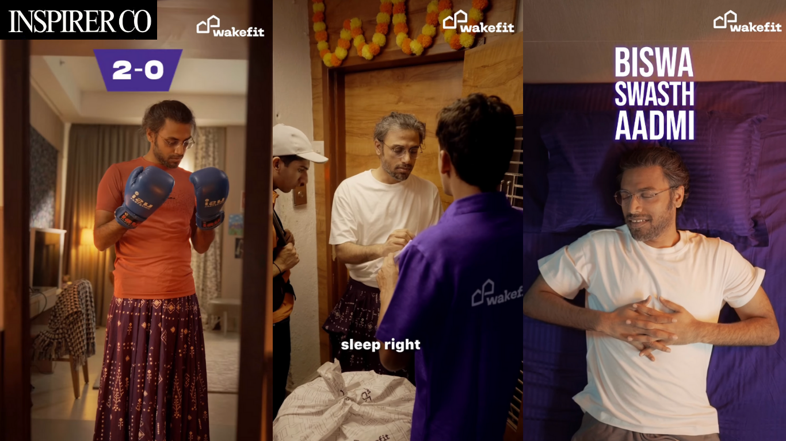

In 2025, India’s festive season looks different. The rush to shop, decorate, and celebrate has slowly given way to something quieter, more reflective. Wellness, balance, and humor now share the same stage as gifting and glitter. Wakefit’s Diwali campaign with Biswa Kalyan Rath captures this cultural shift with rare precision and charm.

The film doesn’t preach mindfulness; it laughs at our lack of it. Through Biswa’s comic portrayal of a sleepless shopper making impulsive midnight purchases, the ad mirrors modern India’s fatigue and overdrive. The delivery bell rings, chaos ensues, and amidst the laughter lies a truth: better rest makes for better decisions. Wakefit’s message lands gently. Good sleep is not indulgence, it’s intelligence.

What makes this campaign stand out is its simplicity. No over-the-top sets, no emotional manipulation, just keen observation of behavior and a touch of satire. The humor works because it’s painfully relatable. It takes India’s collective insomnia and turns it into cultural insight. Instead of selling mattresses, Wakefit sells mindfulness, showing that wellness can be witty and self-care can still be entertaining.

This creative move aligns perfectly with the new festive rhythm, one where brands are moving beyond consumerism to conversation. As *Economic Times Brand Equity* noted, Wakefit’s campaign signals a new era of festive storytelling in India: one that celebrates consciousness over chaos. For marketers, it’s a reminder that emotional engagement doesn’t always require tears; sometimes, laughter works better.

Wakefit’s collaboration with Biswa Kalyan Rath is more than an ad; it’s a cultural case study. It reflects the growing desire for slow living in a fast economy, where mindfulness, humor, and authenticity now define what celebration means. As the festive calendar stretches from Diwali to New Year, this campaign stays relevant, reminding India that sleep, not splurge, is the real luxury of the season.

**References:** Campaign Source: [Campaign Brief Asia](https://campaignbriefasia.com) Coverage: Economic Times Brand Equity  
 Watch the film: [Instagram Link](https://www.instagram.com/reel/DP3G9UNEQRz/?utm_source=ig_web_button_share_sheet)

### **Article 2 — From Sonpari to Pistachio Chocolates: How Quick Commerce Is Powering India’s New Gifting Culture**

### **SEO Title:** From Sonpari to Pistachio Chocolates: How Quick Commerce Is Powering India’s New Gifting Culture

### **🪔 Slug (URL-friendly):**

india-new-gifting-culture-quick-commerce-2025

### **🛍️ Meta Description:**

From Diwali to New Year, India’s festive gifting is being redefined by quick commerce players like Blinkit, Swiggy Instamart, Zepto, and BigBasket and now blending nostalgia, curation, and speed to create a mindful new festive economy.

### 

Festive gifting in India is evolving, yet tradition remains its emotional core. From Diwali to the winter wedding season, and from Christmas to New Year vacations, celebrations are becoming more curated, intentional, and expressive of individual taste. Quick commerce platforms like **Blinkit, Swiggy Instamart, Zepto, BigBasket Now, and Dunzo Daily** are redefining how India celebrates offering not just convenience, but curated emotion. Their 2025 festive hampers reflect this transformation beautifully, blending nostalgia with modern aspiration. Sonpapri and Kaju Katli remain the sentimental base, while artisanal chocolates, vegan truffles, gourmet coffee, and scented candles have become the new markers of care *(Indian Retailer)*.

Instant delivery no longer compromises sentiment; it amplifies it, turning gifting into a thoughtful ritual. The evolution from mass-produced mithai boxes to handcrafted pistachio chocolates in minimalist pastel aesthetics mirrors India’s hunger for heritage fused with global design sensibilities *(Times of India)*. As platforms compete on curation, speed, and emotional resonance, they’re not just fulfilling orders; they’re shaping a **new festive economy** driven by mindfulness over materialism. From a Blinkit hamper to a Wakefit comfort gift, or even a quiet self-care ritual, today’s celebrations are less about grandeur and more about genuine intention *(Curly Tales)*.

**4. Inspirers (Top Features + People their journeys)**

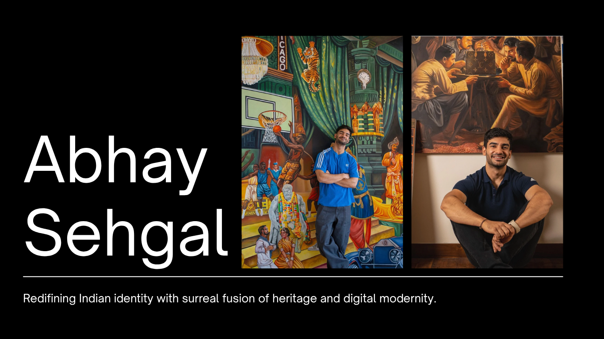

## **Abhay Sehgal: Reimagining India Through Contemporary Art and Code Brown**

**Abhay Sehgal** is one of those artists who makes you see **India in a different light**. He doesn’t just paint or make visuals; he creates worlds where tradition and modern life meet and talk to each other. He studied at the School of the Art Institute of Chicago and works out of Delhi, but what strikes me is how his work feels so grounded yet so imaginative. It’s not about the past or nostalgia; it’s about how India can feel alive and evolving in the moment through art.

His art often takes familiar things, Indian motifs, architecture, and textures, and then twists them in ways that make you stop and think. There’s surrealism, **yes,** but also a lot of feeling and storytelling. It’s like each piece is asking you to notice yourself, your memories, and the world around you in a slightly different way.

What’s really exciting is that he’s also the mind behind **Code Brown**, a creative collective and brand that carries this same philosophy forward. It’s playful, experimental, and bold. It’s about celebrating India as it is right now: raw and layered, chaotic and poetic. His work through Code Brown makes you think about identity and culture differently. It feels unapologetic and alive.

Sehgal’s work doesn’t just stay on the wall or in a frame; **it pulls you in** psychologically and emotionally. He draws from Indian mysticism, psychology, and the stories we all carry in small ways, so it feels personal yet universal. His visuals invite reflection and curiosity. You can get lost in them, but also feel seen.

For anyone following contemporary Indian art, collectors, creatives, or just people curious about culture, his work opens up a conversation about how India can be represented today. Not stuck, not frozen, but **fluid, thoughtful, and inventive**. And it’s exciting because it feels like a movement, something that’s larger than one artist alone.

**SEO Keywords:** Abhay Sehgal, Code Brown, contemporary Indian art, India, Indian visual artists, Indian design collective, Indian cultural creativity, modern Indian art, Delhi contemporary art, Indian art trends, Indian creative brands, Inspirer.

**5. Portfolio (Community People here can curate their own portfolio and offer their service or consultation)**

**Creative Profile Network | People | UGC Content Section**

**+**

**Debate Section Under This**

**Objective:**

Create a space for users to engage in open-ended, constructive discussions on creative, marketing, cultural, and professional topics. The focus is on respectful conversation and idea exchange.

**Features:**

•Section where the founder puts the Debate or topic of the day with title, short description, and date

• Users can post comments and replies in threaded format

•Like/upvote insightful contributions

•Admin/moderator can highlight key comments

•Mobile-friendly, minimal design consistent with Inspirer Co branding

•Clear guidelines for respectful participation